Policy Management and Policy Verification in Pega

You can verify access control policy by testing them to see whether they grant or deny access to a specific case for a specific user.

In Dev Studio click Configure > Org and security > authorization > policy based access > policy verification.

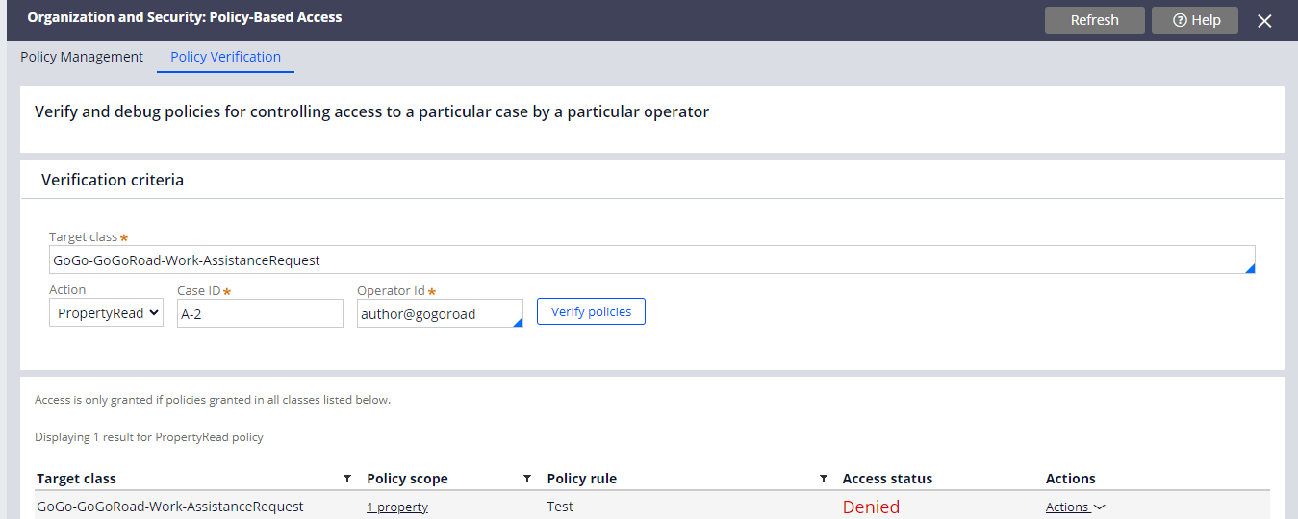

So you need to specify the target class and the action and operator ID and click on Verify Policies and it will show the access status and also actions to be performed.

We also need to create instances of Access control policy and access control policy condition

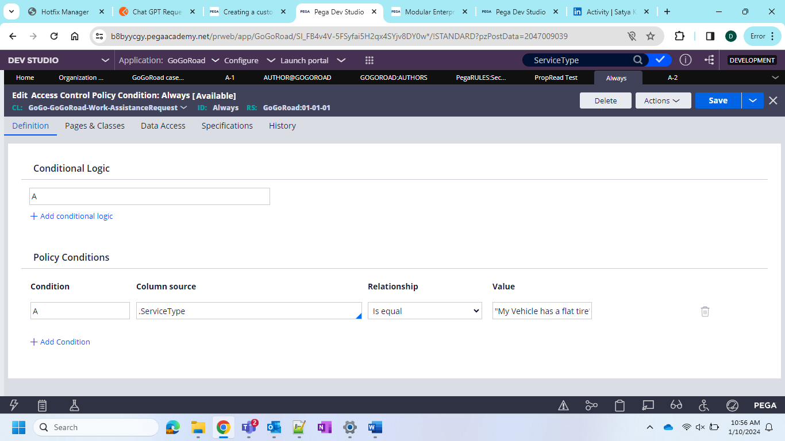

So now after the creations you need to go to the wizard and give the class and action to be taken and the operator ID to which it belongs and after verified it will show the results as below

And also in the policy management it will show actions and conditions

So this is about policy management and policy verification in Pega